Date: | Location: Any Town | Task: Administration

Crew : Cashier, Office Staff | Temp: 68⁰  3:00 PM

Describe Potential Hazards/Controls

Hazards/Controls ( SAMPLE)
Hazards | Controls
- Angry Citizens’ confrontation | - administrative - Training – Workplace violence  - Engineering – Ballistic Shields  - Engineering - Panic Button
- fatigue Standing/Sitting | - administrative – Safe Work Practices, Mini breaks  - Engineering – Floor Mats, Proper seating
- ergonomic hazards | - engineering – Proper Workplace Set Up
- Strains & Sprains | - Warm up & Stretching Exercises

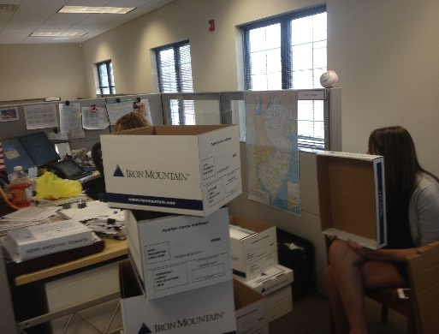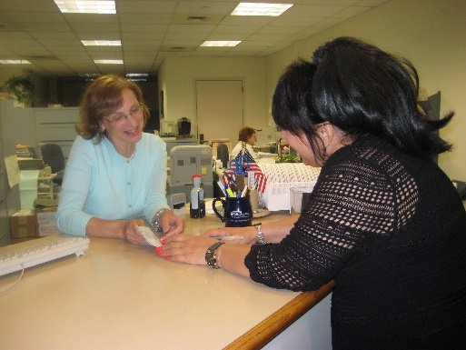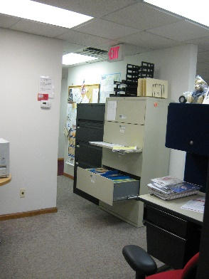

Describe Task: Maintaining Customer relations, Collecting Fees

As I approached the office I noticed that each person maintained their own workstation. My observation is focused on the individual manning the counter while residents make their tax payments or pay for other services. The counter is not protected by ballistic Glass which would prevent any contact with disgruntled residents. Employees have access to a panic alarm which is directed to the police department on the first floor. I would point out that the floor is tiled and there are no mats to help reduce fatigue while attending to the window. The area below the counter would benefit from some housekeeping, there are files in boxes stored below which requires the cashier to lean over the counter to accept payments. The desk belonging to this individual is cluttered, with electrical wires and storage is cluttered beneath the desk.

Sharp items such as letter openers, pens, and pencils protrude from a coffee cup with points facing up, which could present an impalement hazard.

There is a space heater which won’t be used for several months also stored in the workspace.

The chair is set too low for the position of the computer monitor and keyboard. The monitor is not adjusted for proper height and is too close to provide proper Eye relief.

There were several file drawers in various stages of being open, with the second lowest being out several inches.

Other observations include cradling the phone between the ear and shoulder.

Recommendations:

My recommendations would be:
- Install a barrier between the residents and cashier
- Install fatigue mats to stand on behind the counter
- Enact a housekeeping policy to prevent the buildup of clutter
- Remove unused appliances from the work area.
- Enroll employees in Office Safety Programs as well as Workplace Violence training
- Conduct training in the proper work station set up.

Observer:

________________________
Your Name
Your Position
Your department
Narrative Format JSO Instructions – Revised 8-21-13

Consider the task to be observed:

Complete Date, Time, Crew information etc.

Begin by identifying all known and potential hazards associated with the job.
List the kind of control(s) used to reduce or eliminate the hazard, i.e. Engineering control, Administrative control or Personal Protective Equipment (see below for leaf collection). Note: The Hazards and controls listed below are for sample purposes only and not necessarily appropriate for use in all Job Site Observations. Hazards and controls should be identified based on the task at hand.

Hazards | Controls
- Traffic – Struck By, Mobile Work Zone | - Engineering Control - Amber Lights, PPE - Hi-Visibility Clothing
- Flying Particles | - PPE - Safety Glasses, Gloves, Long Pants/Sleeves
- Noise | - PPE - Hearing Protection
- Back Injury, Strains & Sprains | - Engineering control – Gas powered blowers
- Breathing Hazard | - PPE - Dust Mask
- Fatigue | - Safe Work Practice – Speed, substitution of hand tools

Take several pictures to document conditions or work practices.

- Describe the tasks being performed. Include information on how the controls are being used.
- Describe any deficiencies in procedure or controls.
- Describe good behavior.
- Describe conditions, i.e. weather, lighting conditions, heat, cold, etc.

Include personal observations on procedures being employed.

In short, the JSO should tell the story of the task at hand. Who, what, when, where and how of the task being performed.

Done correctly, the JSO becomes an effective tool which can be utilized in several areas.

- The JSO will first give the observer an insight as to how the jobs are being performed in regard to safety and adherence to procedure.
- It will help identify areas of need such as training, equipment or safe work practices.
- It satisfies the requirements of a hazard assessment as required by PEOSH.
- Observations can be used to describe a workers position to a physician when trying to offer transitional duty or determine fit for duty.
- It can be used as material for a Tool Box Talk to review the results.
- Improve morale by pointing out what is good as well as what is deficient.

